**Phase3-Practice Project: Assisted Practice**

**JMeter:**

Write a program to demonstrate the use of thread group plugin in JMeter.

**Thread group plugin:**

We have to download plugin manager jar file for jmeter and add plugin manager to jmeter.

Installation and Usage

Download the Plugins Manager [JAR file](https://jmeter-plugins.org/get/) and put it into JMeter's lib/ext directory

<https://jmeter-plugins.org/wiki/PluginsManager/>

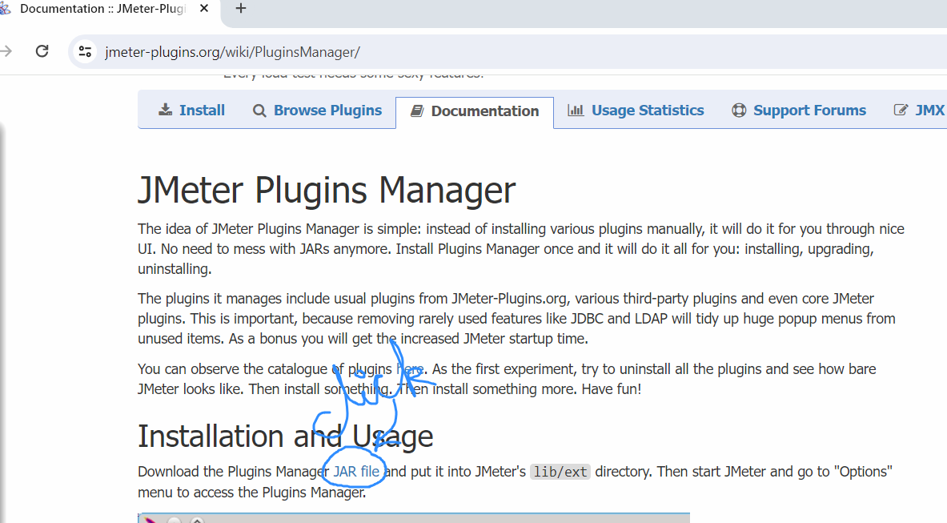

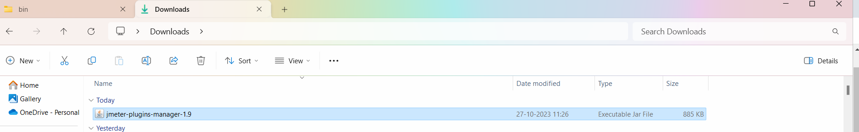

Copy this in jmeter folder🡪 lib->ext folder

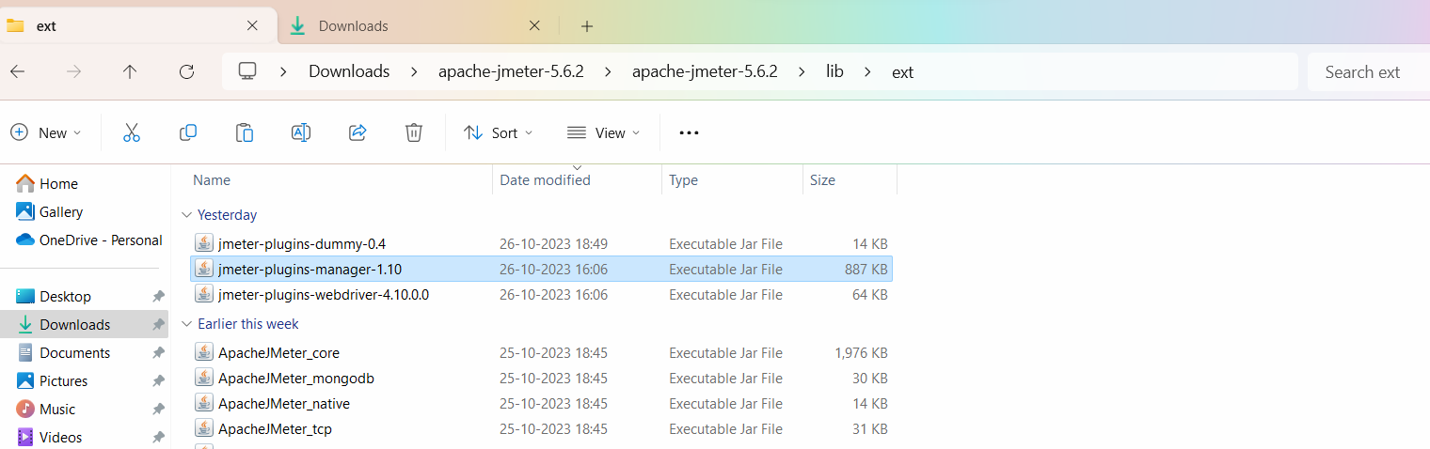

Stop and restart jmeter

In Jmeter 🡪 go to Options -> you will see the Plugin Manager

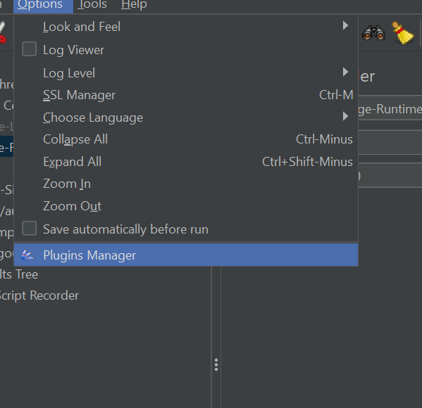

Click on plugin manager🡪 go to available plugins 🡪 search for custom thread group plugin

